1. Deploy Services to Azure Container Apps
   * Screenshots of the configuration process for each Container App instance (PetStoreApp, PetService, ProductService, OrderService) on the "Basics", "Container", and "Ingress" tabs.

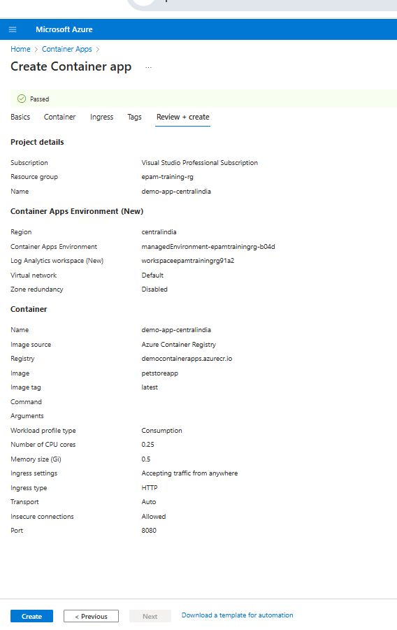

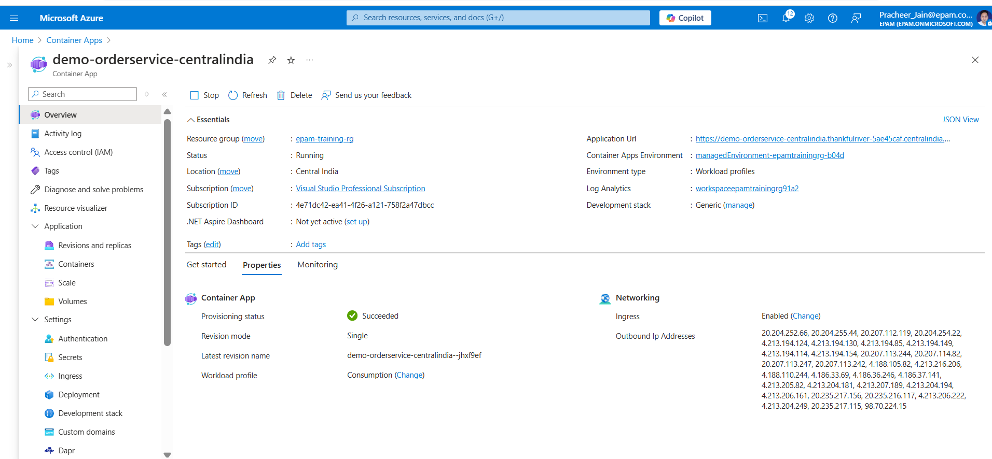

* + Screenshot showing the successful creation of each Container App instance.

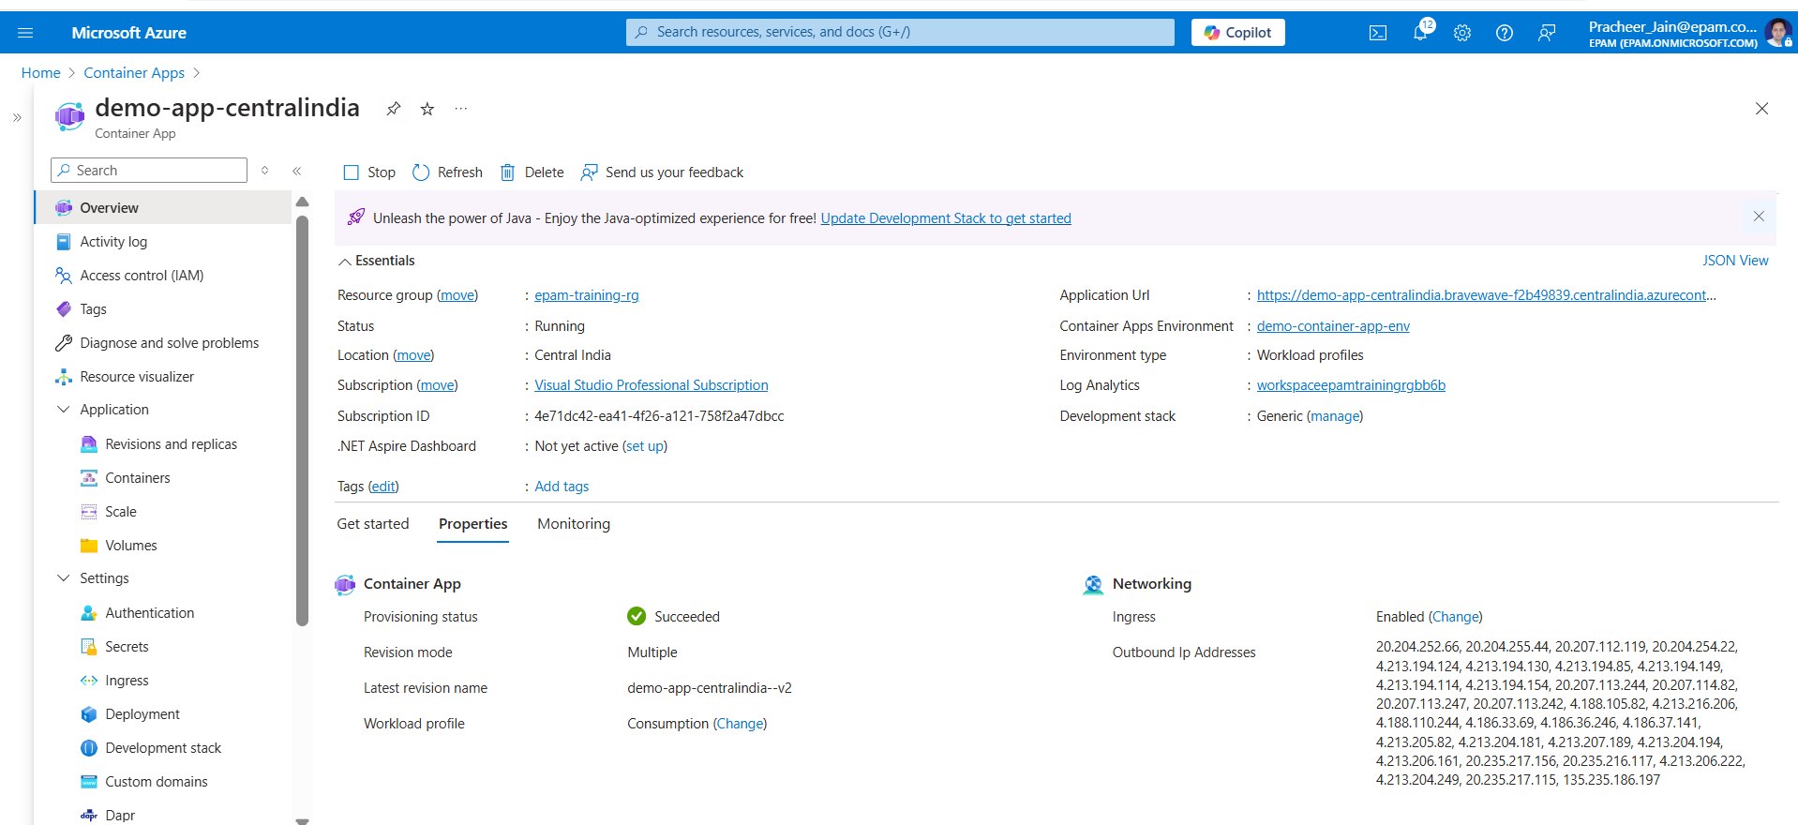

1. Configure Environment Variables
   * Screenshots of the Application URLs from the "Overview" tab.

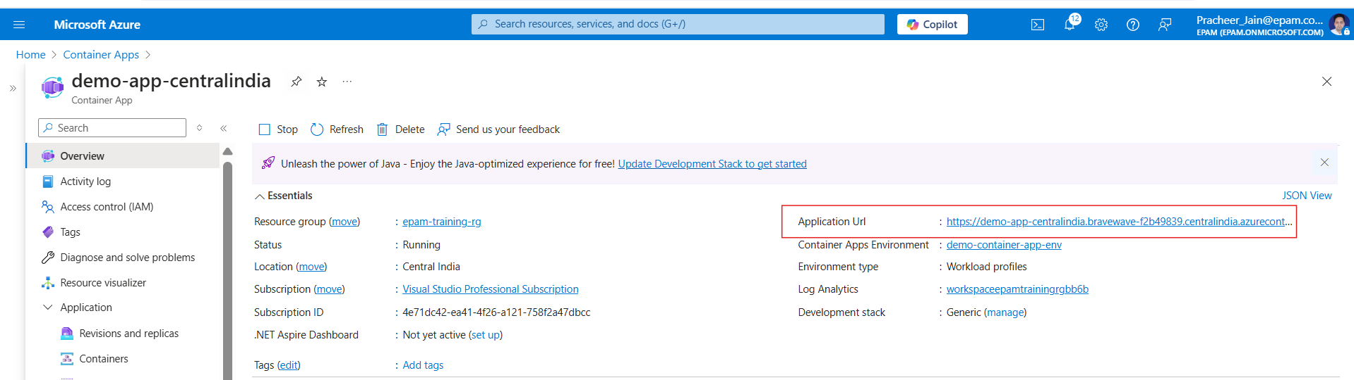

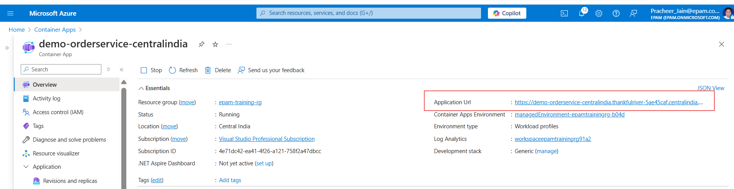

* + Screenshots showing the process of adding environment variables in the "Environment Variables" section.

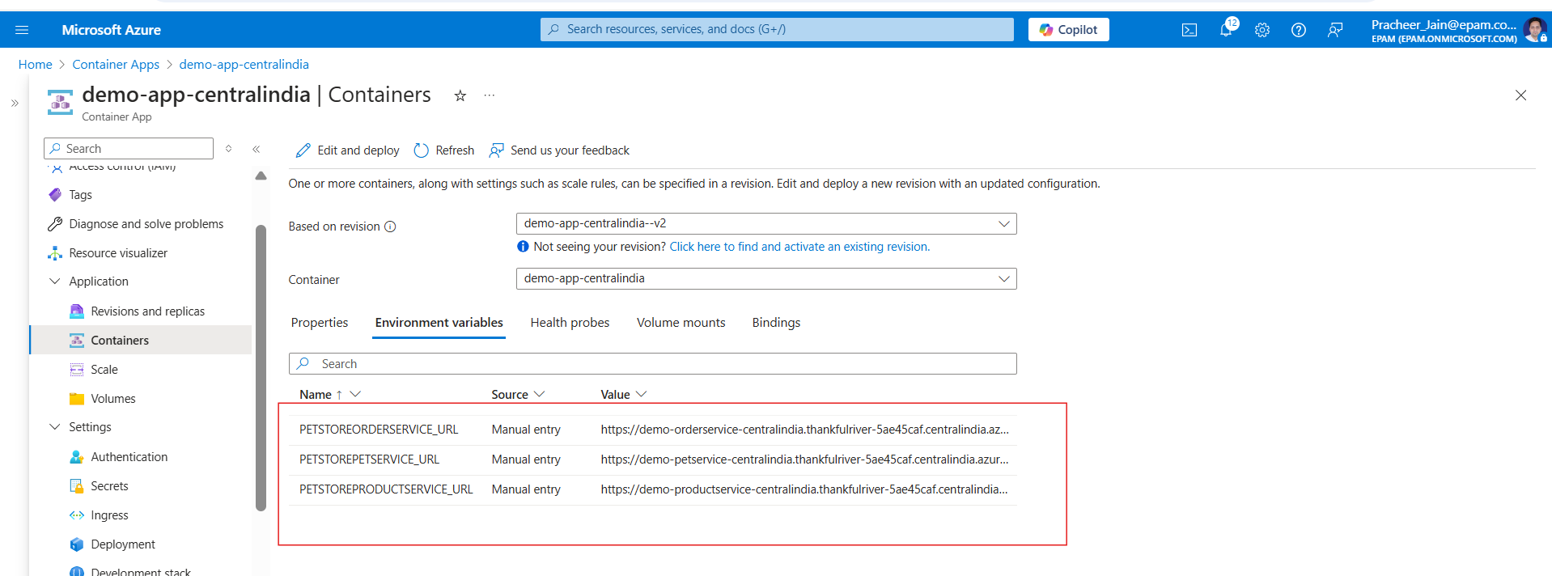

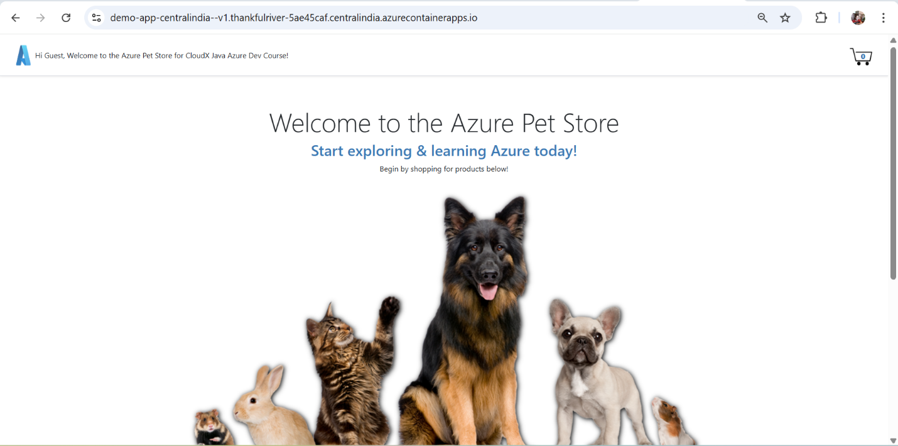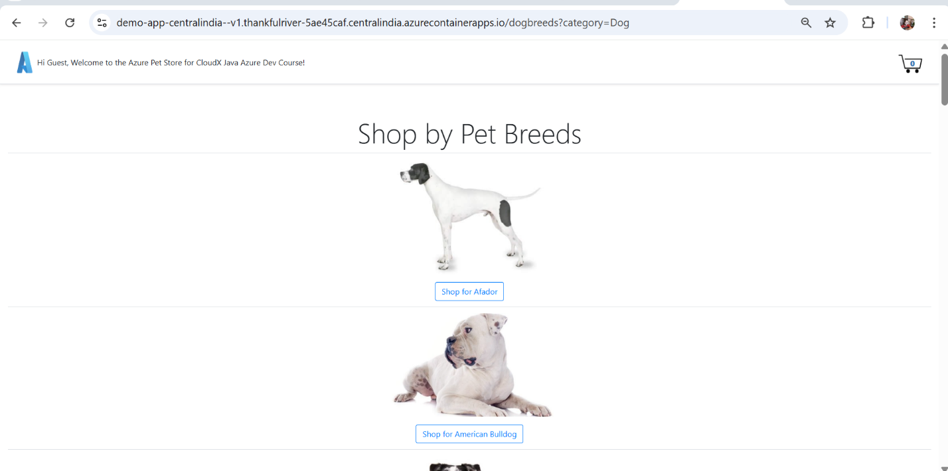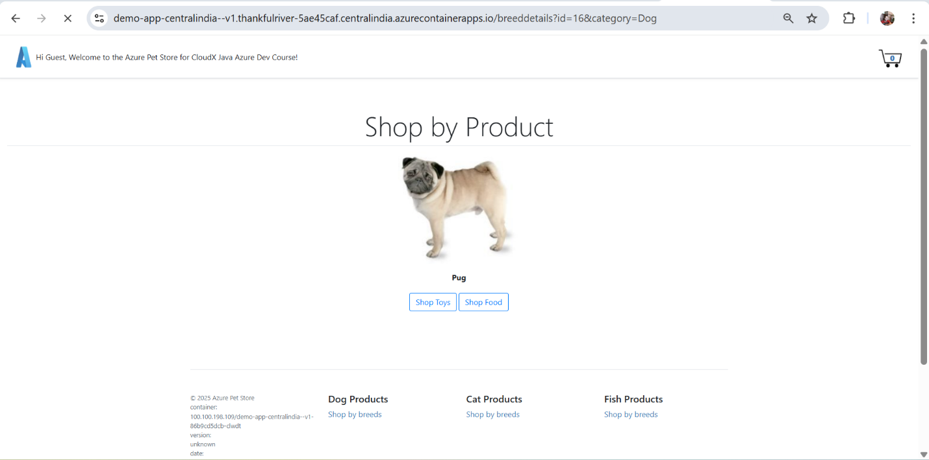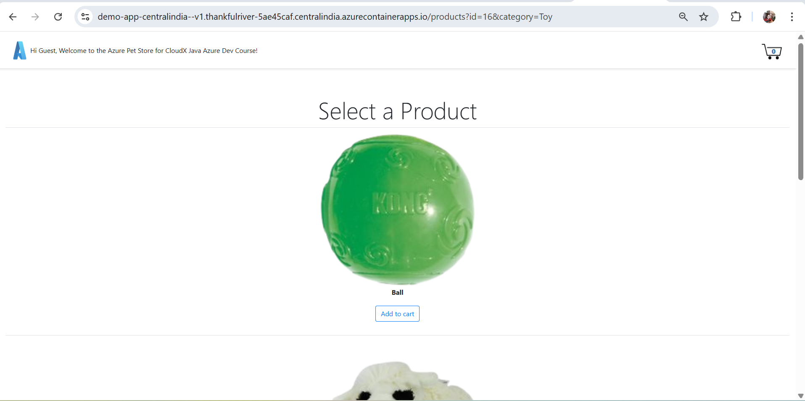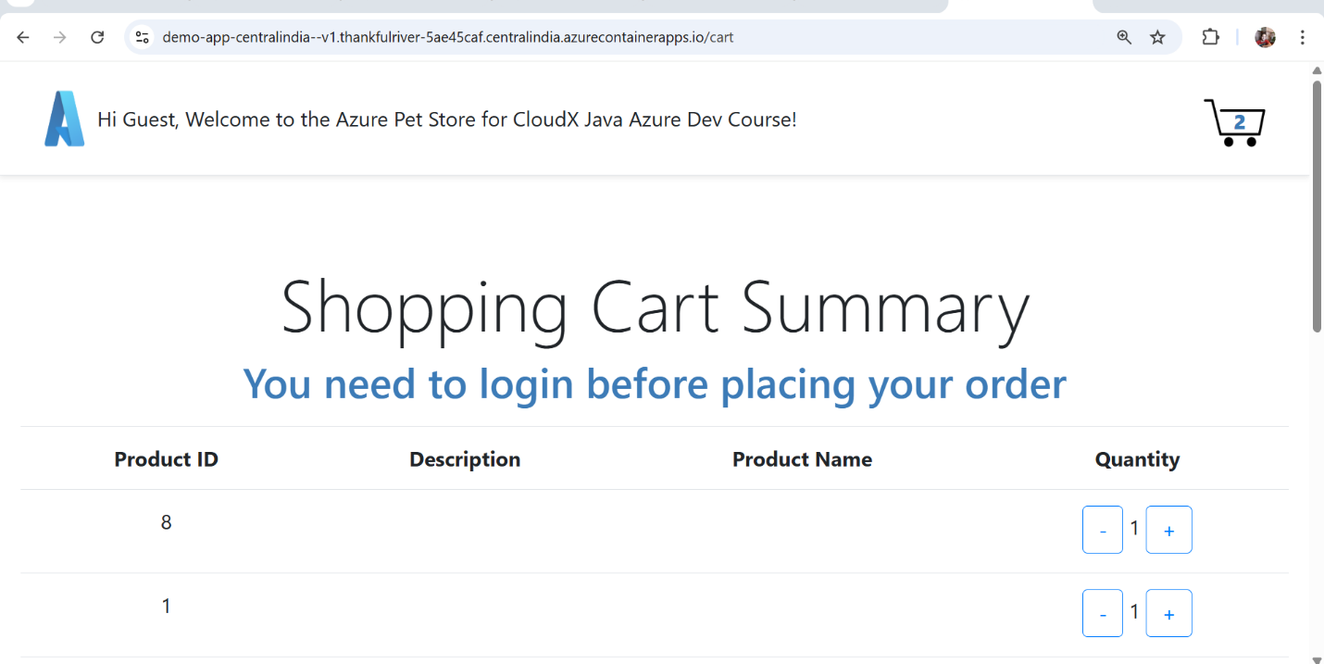

1. Configure Autoscaling
   * Screenshots of the "Scale and replicas" settings for each Container App (PetStoreApp, PetService, ProductService, OrderService).

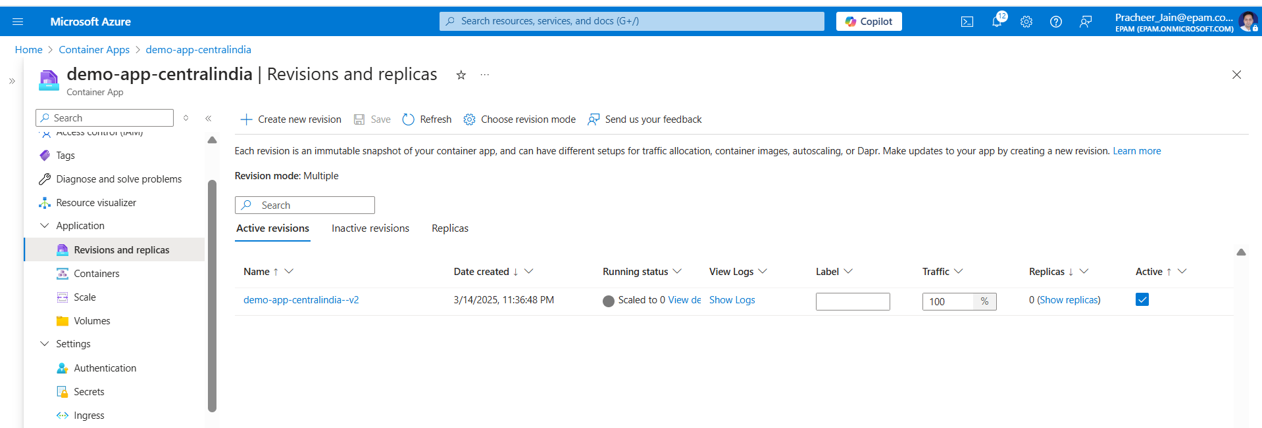

* + Screenshots of the "Add scale rule" configuration for HTTP scaling and concurrent requests settings.

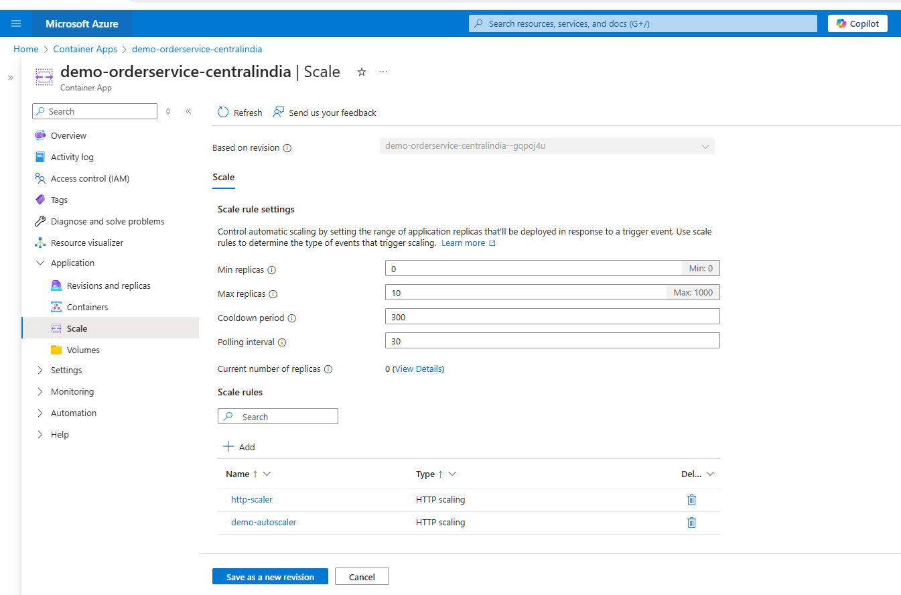

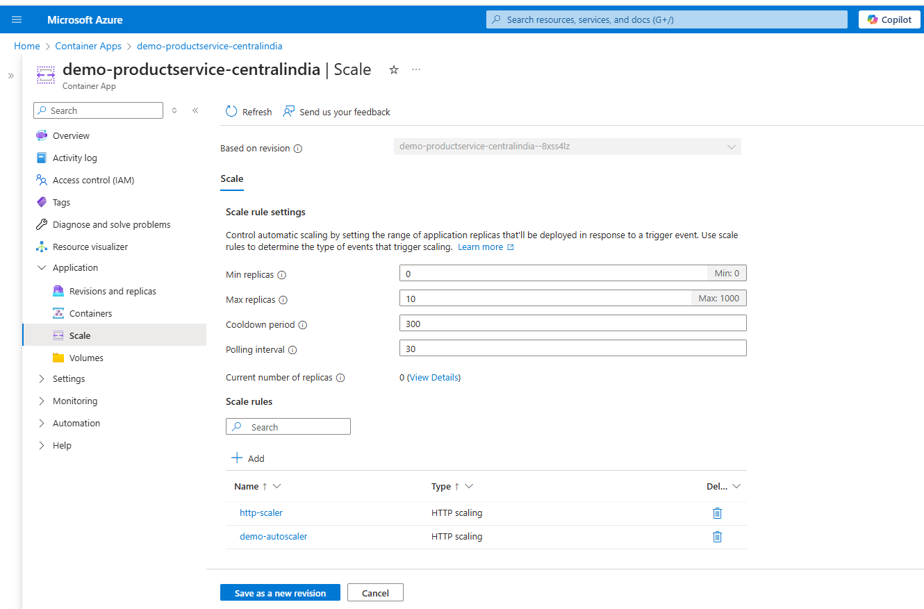

1. Test Autoscaling using k6 Tool
   * Screenshots of Swagger endpoints utilized for testing autoscaling.

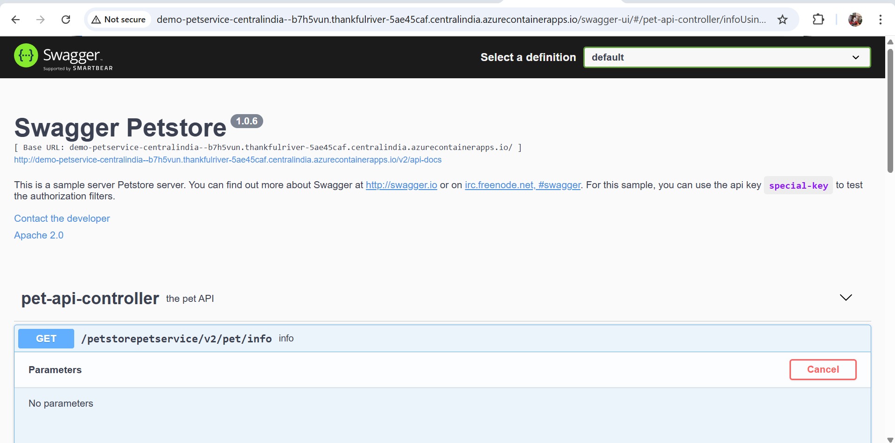

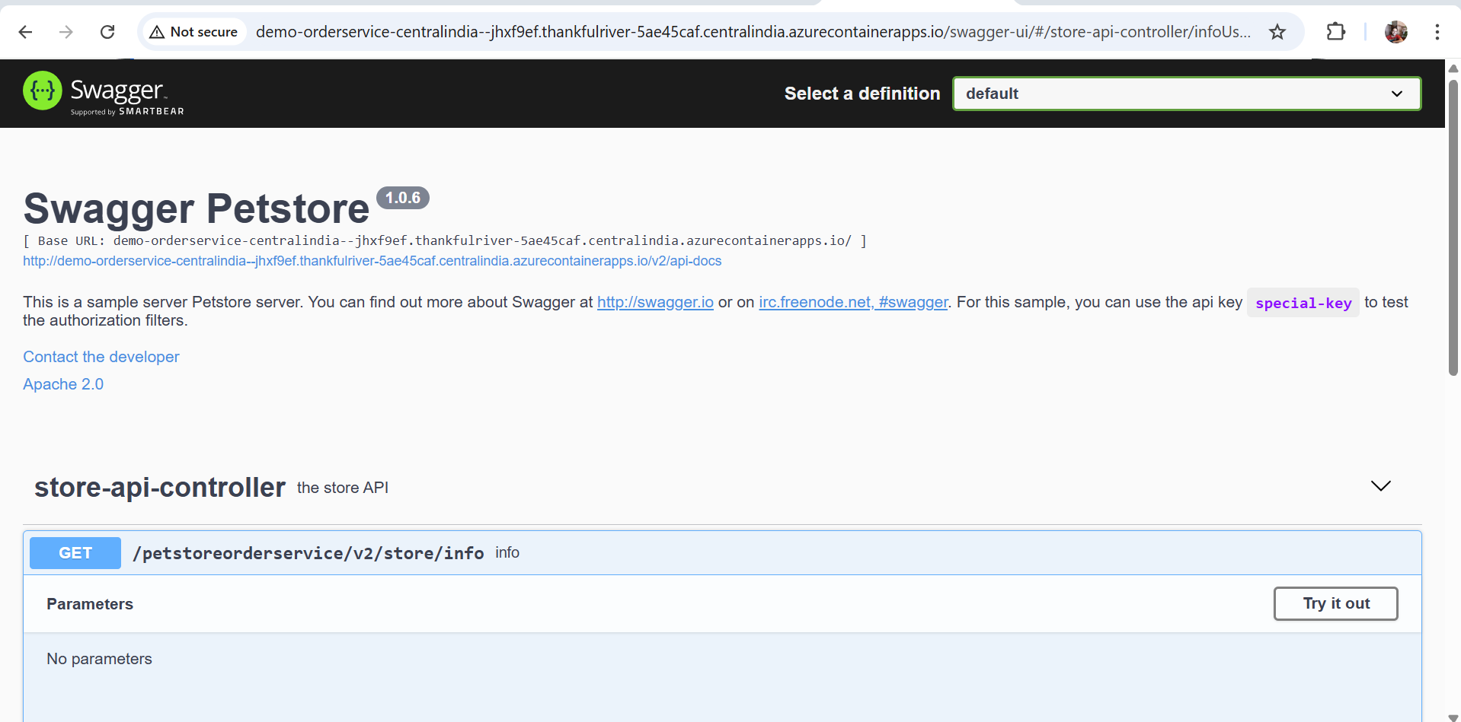

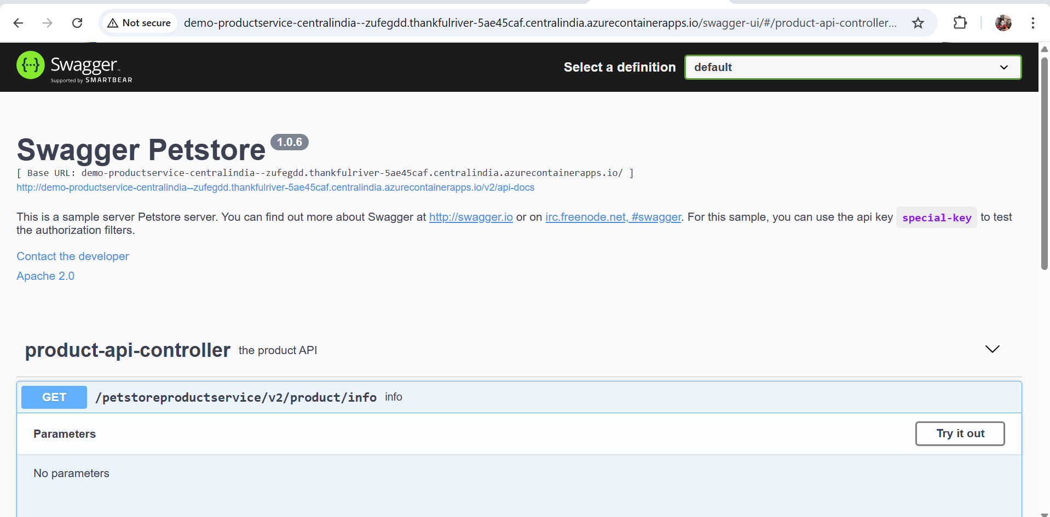

* + Screenshots of the k6 tool in use for testing autoscaling.

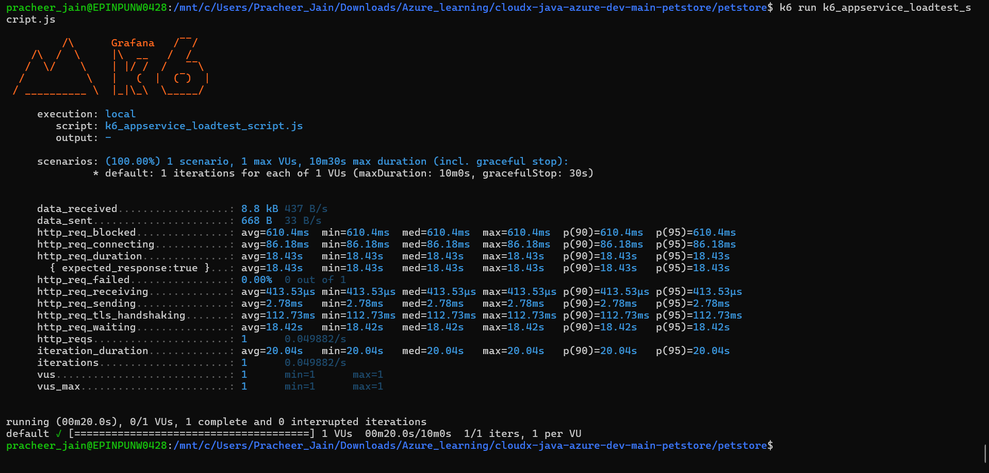

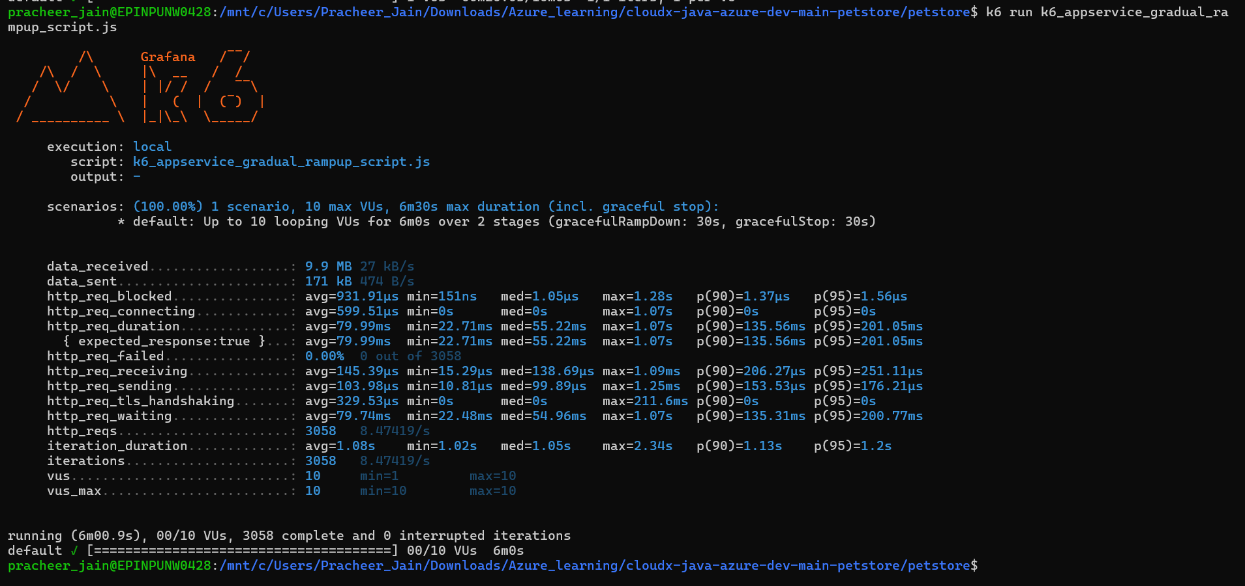

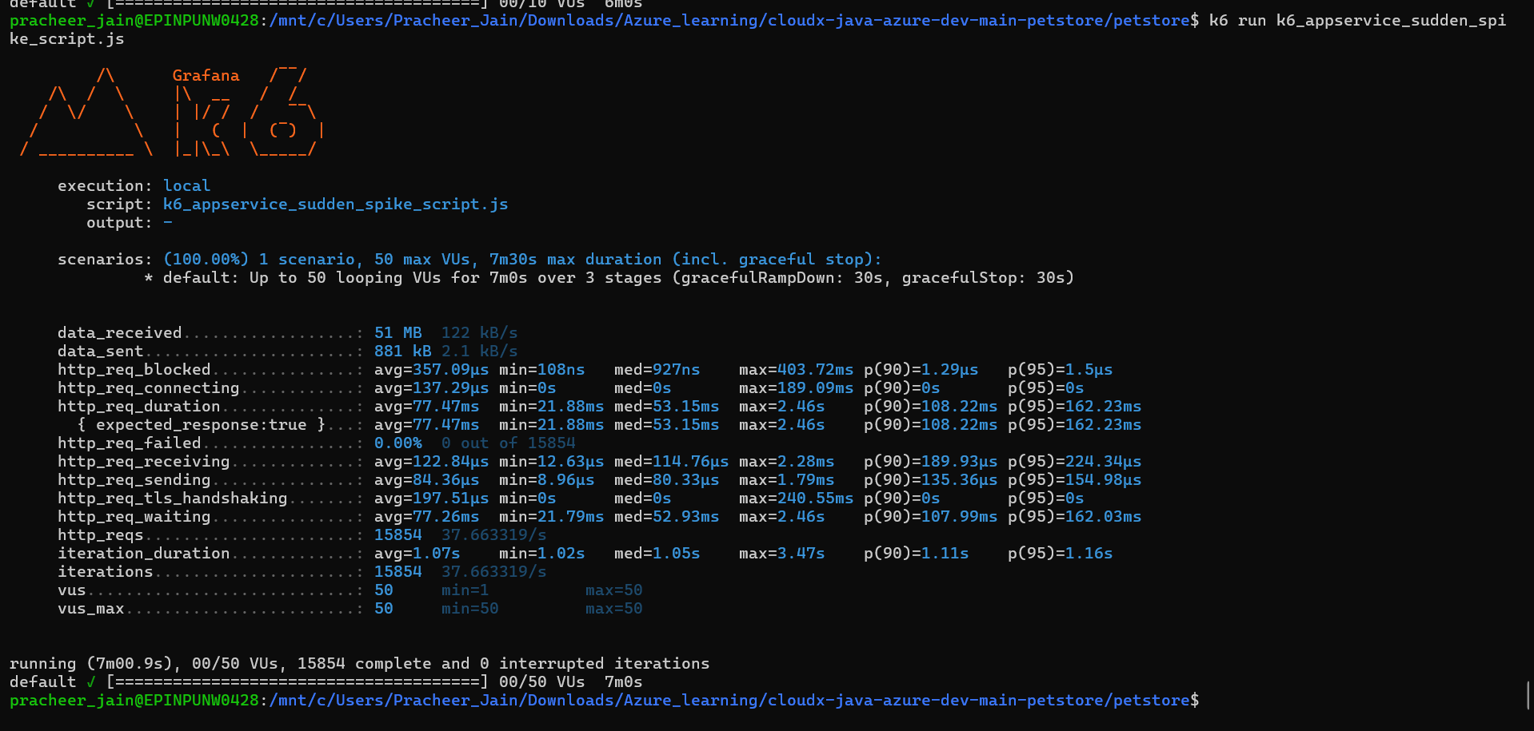

* + Screenshots of the results, particularly showing the scaling behavior under load.

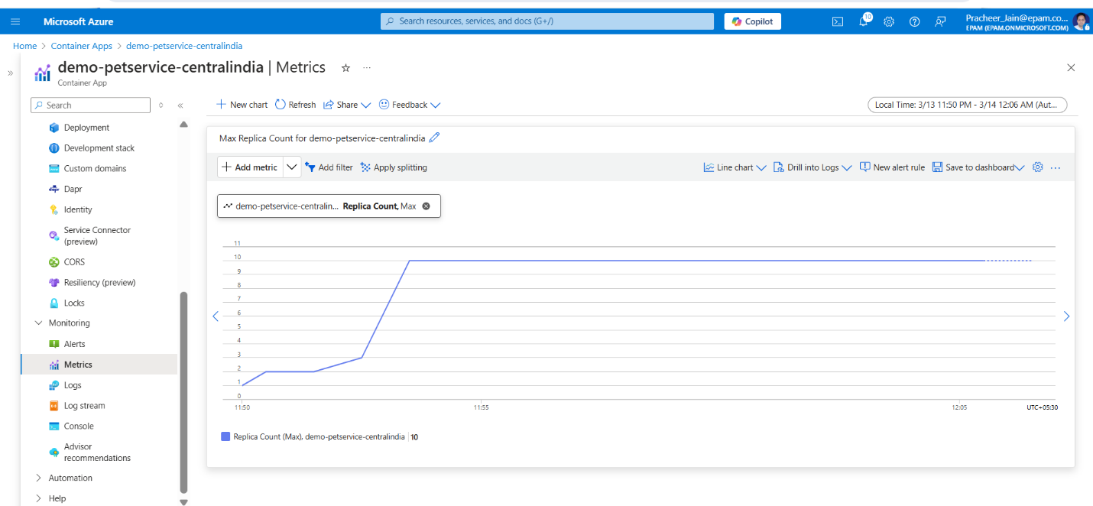

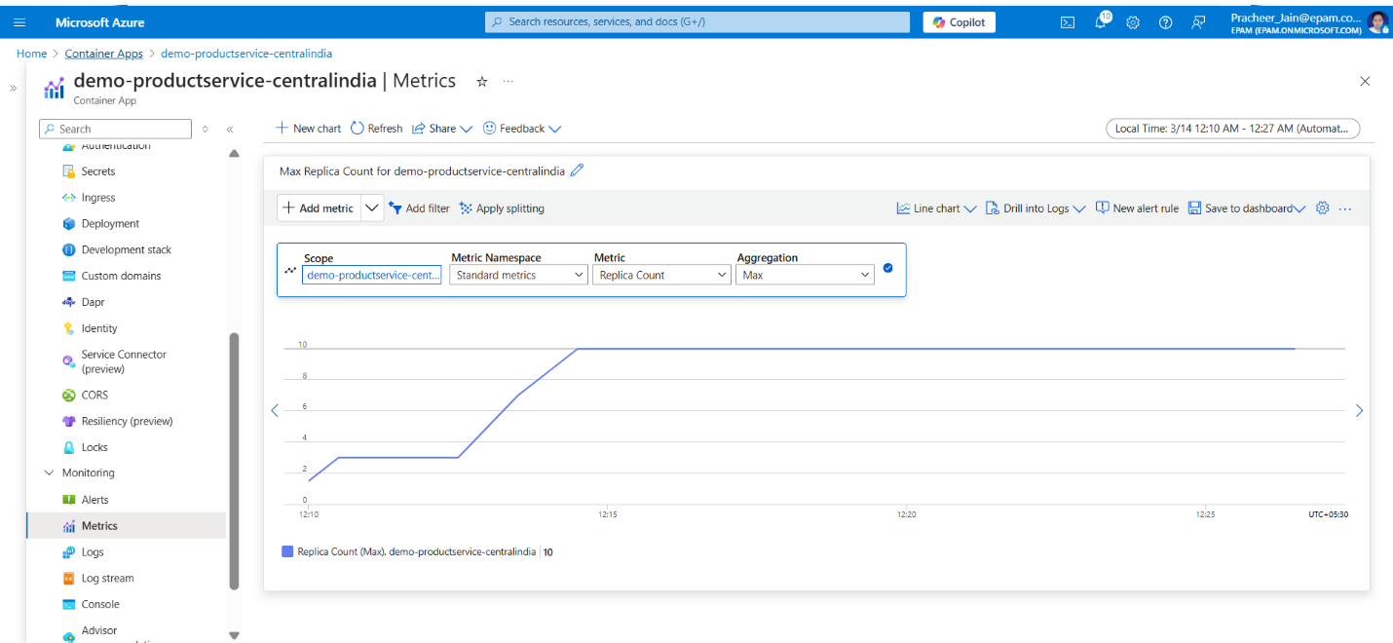

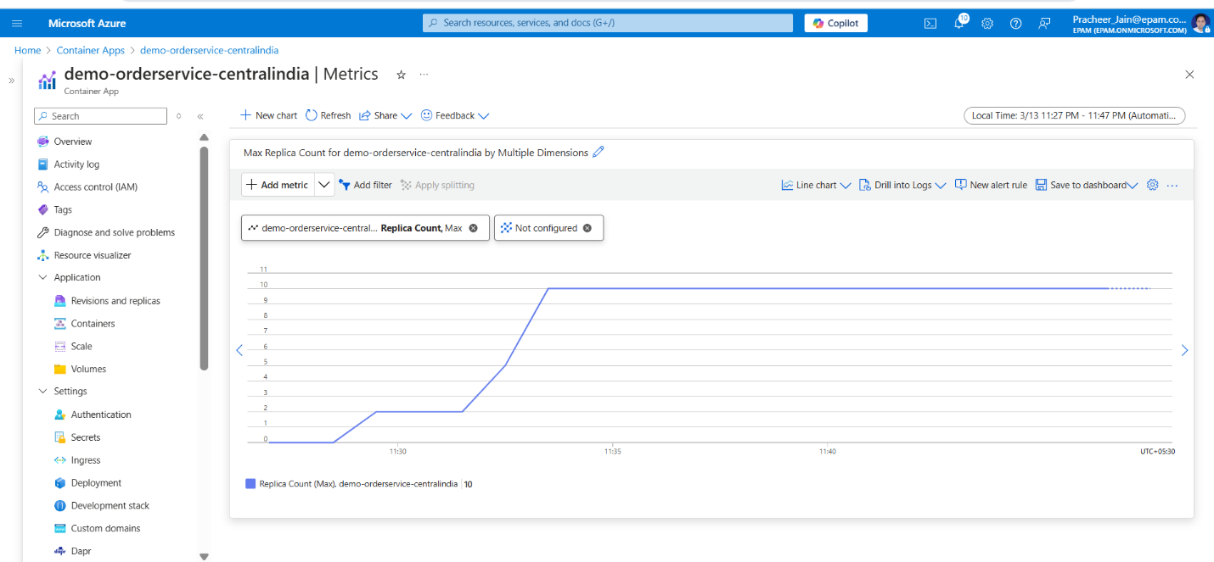

1. Deploy Multiple Revisions Simultaneously for PetStoreApp
   * Screenshot showing the "Revisions" settings with "Multiple" selected as the Revision Mode for the PetStoreApp.

* + Screenshots of the "Create new revision" process, including updating the container image tag and the creation of the new revision.

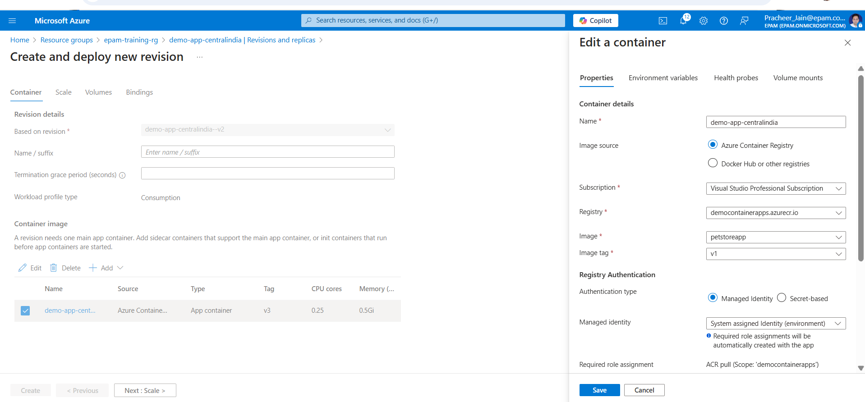

* + Screenshots showing the traffic distribution settings under "Active revisions" for Canary deployment.

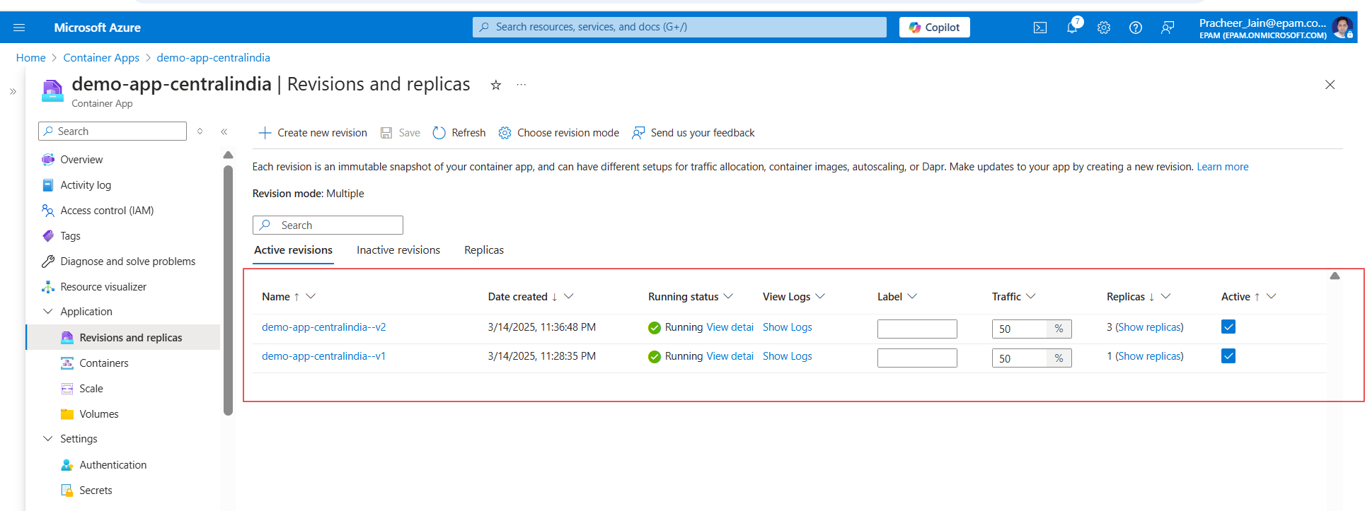

* + Screenshots of the final traffic distribution settings for Blue/Green deployment, with 100% traffic directed to the new revision.

1. Screenshots or GIF-file showing the testing process for the main features of the application.



1. A screenshot showing the list of Azure resources that correspond to the diagram.

